OIC Oracle Managed DR.
Test case: is File Server content automatically migrated in secondary OIC instance when Failover is performed ?
Test done in:
- Tenancy: emeaadsappdevint
- Compartment: gconte
- Oic instance: oic3_dr_primary
- Primary region: Frankfurt
- Secondary region: Amsterdam
Following are file server details.
FQDN:
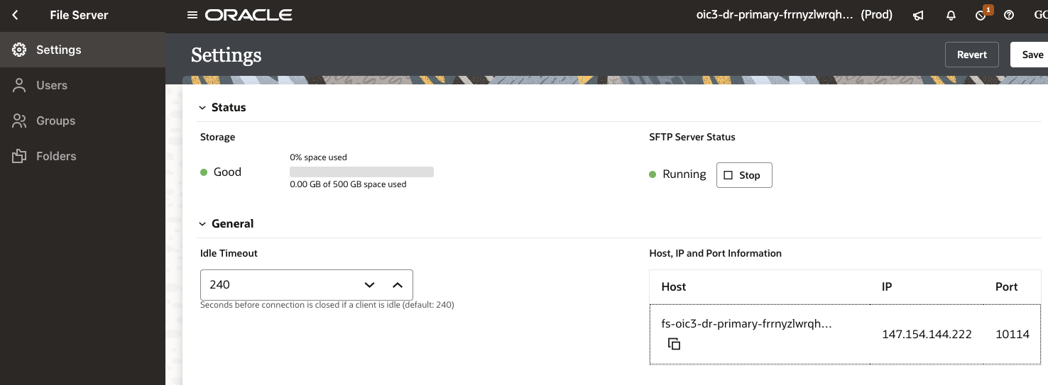
Enabled giovanni.conte@oracle.com for File Server.
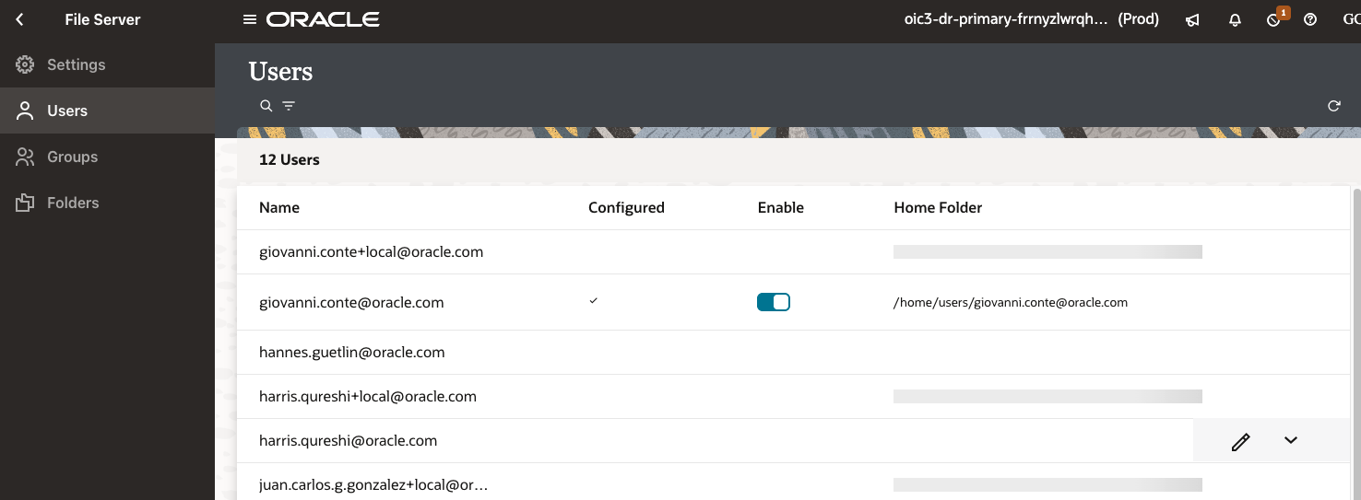

We have following files in File Server (access with SFTP client using Fiel Server FQDN).
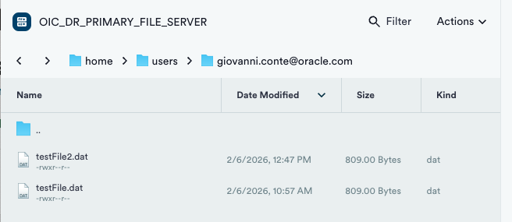

Performing OIC Oracle Managed Failover.

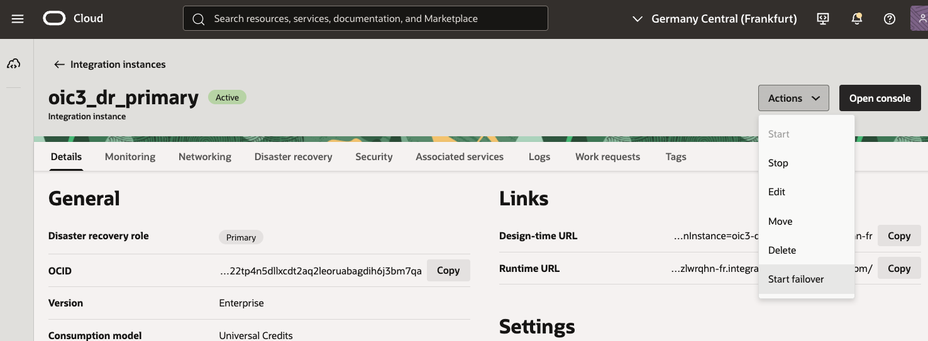

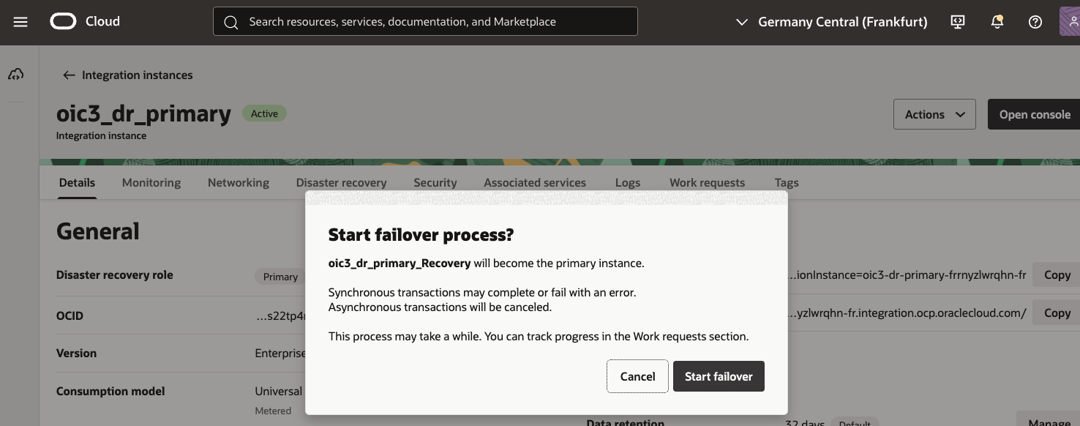

Failover running.
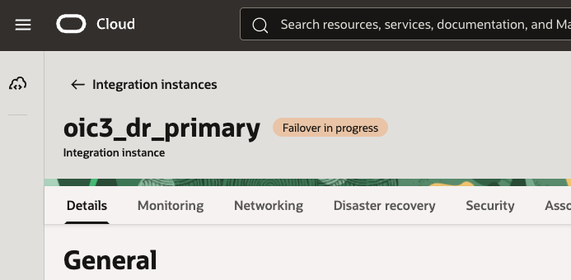

View of instance in Frankfurt Region.

View of OIC instance in Amstwrdam region after Failover completion.

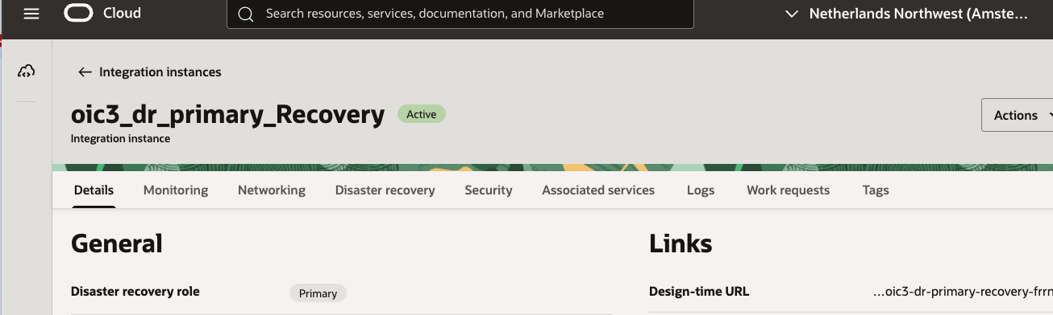

File server different IP (expected) and same FQDN (expected) and same port (expected).

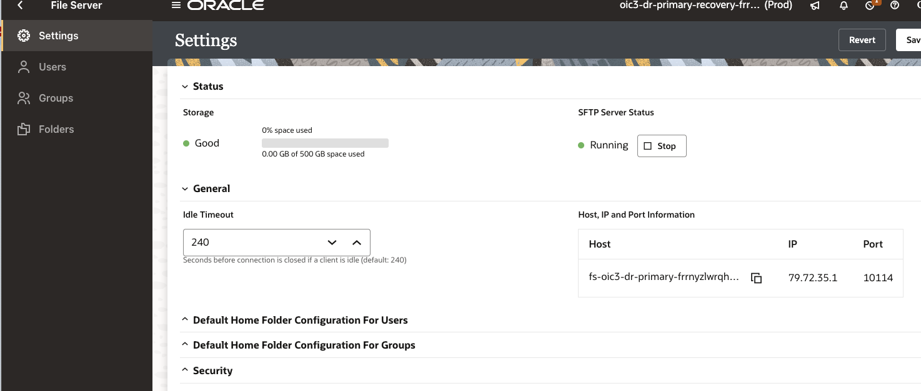

Same user enabled with same home folder and same key.

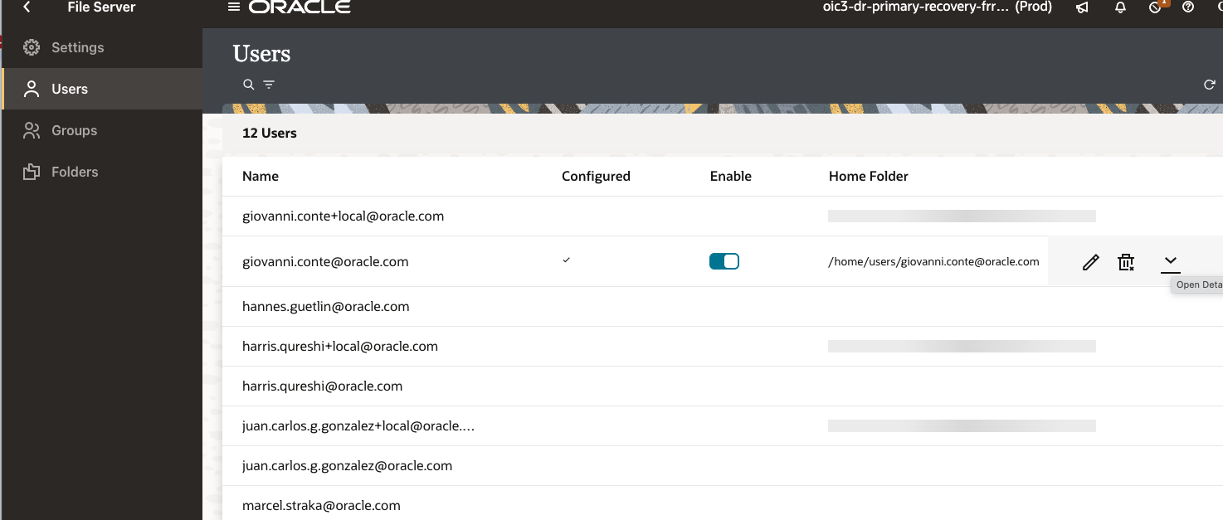

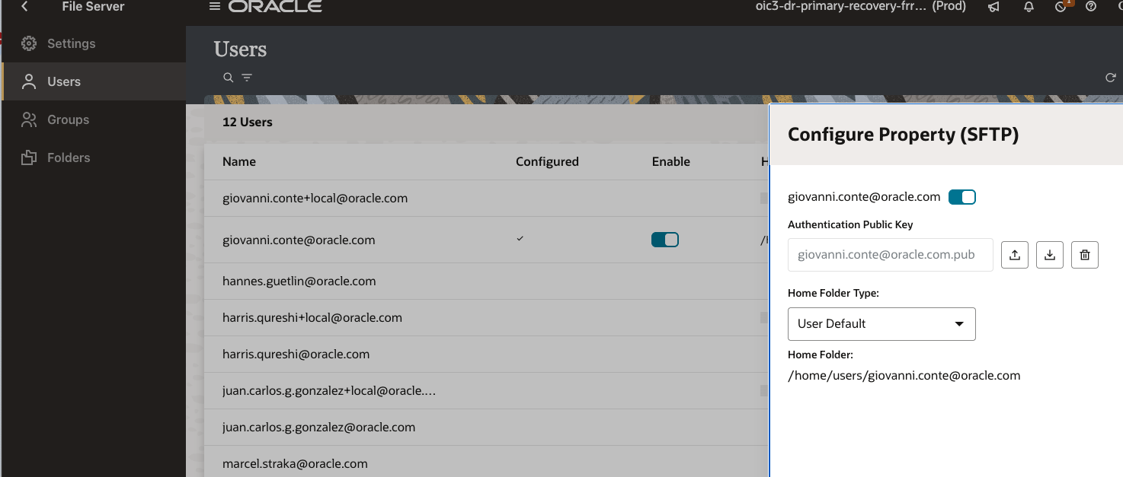

Same files in secondary File server as in primary (accessed obviously through FQDN), same port, same user and SSH key

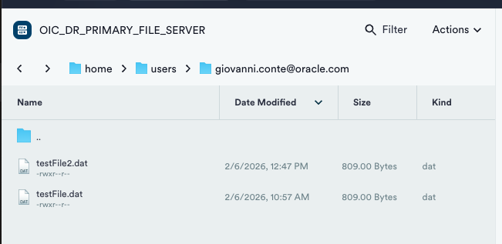

Now adding another file before switchback.

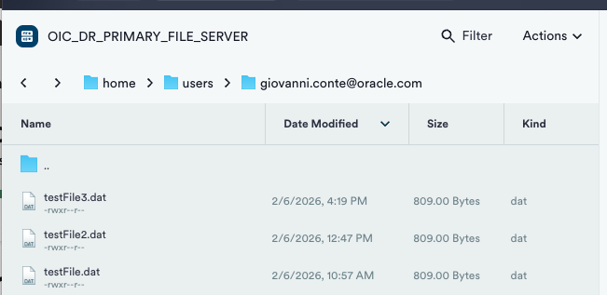

Now performing switchback from Amsterdam secondary instance.

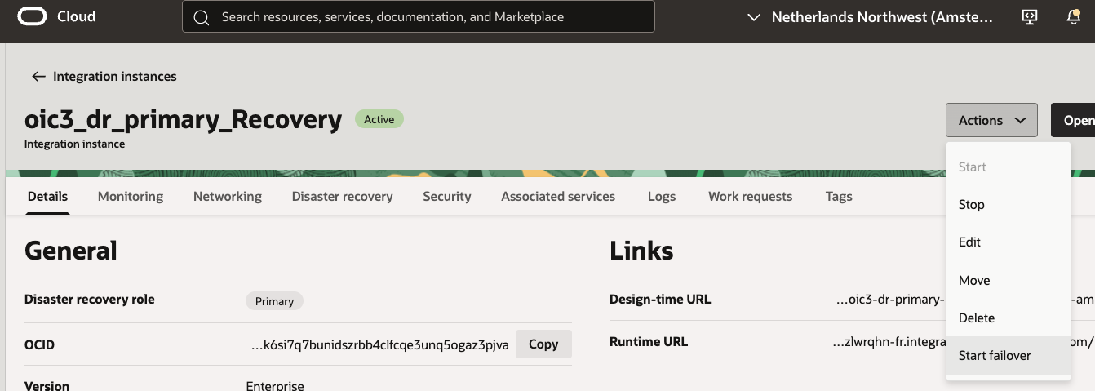

View of instance in Amsterdam Region.

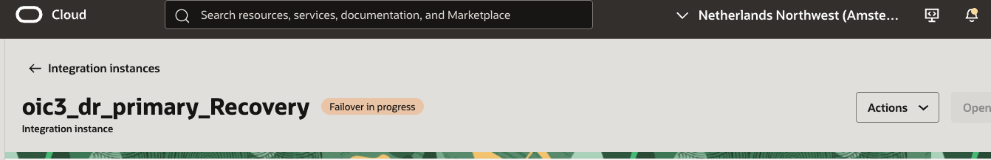

View of instance in Frankfurt Region.

Obviously during failback (also during failover) it was no more available.

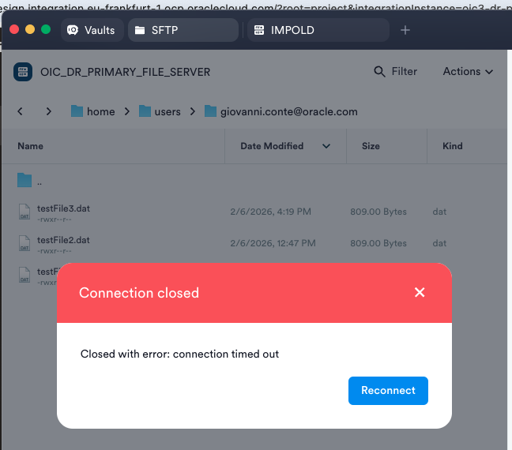

When OIC is Active in Frankfurt, I check again through the SFTP client.
I see the three files, the 2 that were originally in Primary and the one that has been added in Secondary.
